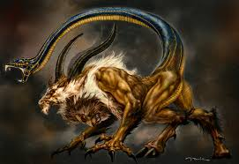
Willow Homework Grid: ‘Mythical Creatures
I I did this independently with no help.
S I did this with some support.
H I needed lots of help and found it tricky.

English |  | Maths |  | Topic/Creative
Reading:  Read and analyse two different explanation texts. Then complete the features table.  Yes No  Topic Title?  Paragraphs organised around a theme?  Opening introductory statement  Time and causal conjunctions  Pictures/diagrams?  Glossary?  Y6: identify any technical language used and research their definitions. | Date:  Comments: | Place Value: Complete these sequences counting back and forwards in 10s:  A - 345,000 ________, ________, 315,000, _______  B - ______, _______, 212,903, 112,903, ________  Can you solve the following word problems?  - A farm sells 247, 592kg of potatoes in one month. How many kg is this to the nearest 10,000 and 100,000?  - 319,046 adults and 129,671 people visit a museum in 1 year. How many people visit the museum in one year to the nearest 10,000 and 100,000? Y6 - How many more visitors would they need to reach 2 million? | Date:  Comments: | Science: Life Cycle Research.  Choose an animal, then take a page in your homework book.  Write the name of the animal and the type of animal.  Research its lifecycle – draw a large circle on the page and divide it into sections where you can draw and write about each stage of its life cycle.  Remember to include the relevant topic vocabulary.  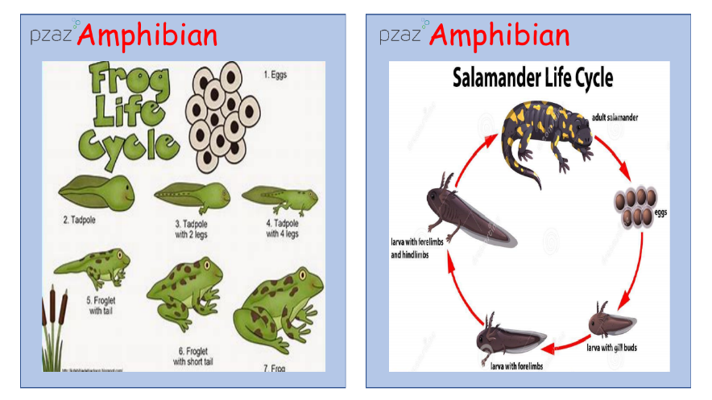 | Date:  Comments:
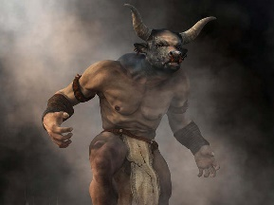  Writing:  Research a mythical creature. Draw it (it can be an image of it in action or a portrait.) Use a range of descriptive vocabulary to write a WANTED poster: expanded noun phrases, similes, adverbials, personification, etc. Think about its appearance, its features, the impact it has on other beings and what makes it unique. | Date:  Comments: | 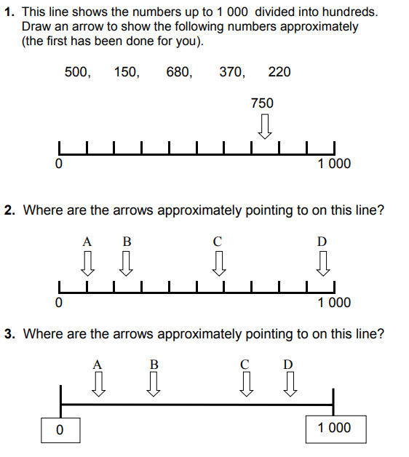 | Date:  Comments: |  | Date:  Comments:
Writing:  Create a detailed and informative safety poster for those living nearby to your mythical creature. Think about how to recognise danger signs, safety-proofing your home, its weaknesses and how to avoid triggering it OR how to use its skills to your advantage! | Date:  Comments:
 |  |  |  | Art and Design: draw a mythical creature/scene containing a mythical creature using ONLY your sketching and shading pencil techniques. How will you create light, shadow and texture? | Date:  Comments:
 |  | Fractions Wk4: Purple Mash tasks set as a 2Do. | Date:  Comments:
Spelling Practice:  Y5 - Make your own spellings crossword or a word search using 8 of the Y5/Y6 words (accommodate to apparent). Y6 - Use 13 of the Y5/Y6 words (accommodate to awkward). Your clues can be synonyms of the word, a definition of the word or a sentence with the word missing. Accommodate, accompany, according, achieve, aggressive, amateur, ancient, apparent, appreciate, attached, available, average, awkward | Date:  Comments:
 |  | 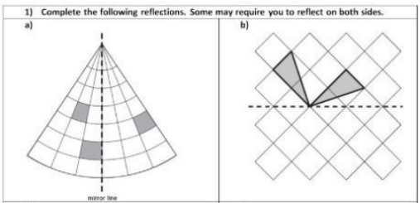  Geometry: | Date:  Comments: | PSCHE / Family Discussion activity:  As a family discuss things and routines that you haven your home to keep you healthy and safe. How do they help you? Why are they there and who decides they should be there? Would you find the same things in everybody’s homes – why/why not? | Date:  Comments:

