Willow Homework Grid: Electricity
I I did this independently with no help.
S I did this with some support.
H I needed lots of help and found it tricky.

English |  | Maths |  | Topic/Creative
Writing: invention with explanation  Can you research for and develop a written explanation of an invention that would help someone from the following categories?  - An assistive device for someone with a communication difficulty.  - An invention that will help farmers use resources more sustainably and reduce their environmental impact.    - A device or system that improves safety in a specific environment, such as a flashing light for cyclists or a device that alerts people to potential hazards | Date:  Comments: | Fractions: multiply and divide by integers  Remember to include a denominator of 1 with your whole number to multiply.  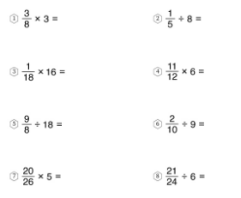  Remember to Keep Flip Change for division!  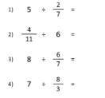 | Date:  Comments: | Money:  Every year 15 schools take part in in a charity fund raiser. Children from the schools donate pennies which are then collected up and sent to the charity.  Mo works for the charity and receives the donations from the schools.  Challenge 1  In 2018 the charity received a total of £1440. Mo noticed that their records show that 15 payments were made (1 from each school), payments were received on 8 different dates, and the same total amount was received on each of those 8 dates.  Find two different ways that this could have happened.  Challenge 2  In 2019 the charity again received exactly £1440, Mo noticed that if the 15 payments were arranged in order from smallest to largest, the amounts went up in equal steps.  Find three different ways that this could have happened.  See: https://nrich.maths.org/problems/charitable-pennies for further challenges related to this investigation. | Date:  Comments:
 |  |  |  | PSCHE / Family Discussion activity:  Discuss how people of different ages have different experiences and needs, and what these might be.  Discuss why it's important to respect everyone regardless of their age and how we can learn from each other whatever age we are. | Date:  Comments:
Grammar: punctuation  Write a short nonsense story based on the idea below and include as many different types of punctuation as you can: full stop, comma, inverted commas, dash, colon, semi-colon, question mark, exclamation mark, brackets.   | Date:  Comments: | Geography:  Can you create a fact file for the River Thames which includes a labelled map showing it’s route from source to sea. Include important points of interest along the way.  Challenge: can you find out the length of the river, decide a conversion scale (E.g. 10km = 1cm) and draw your map to scale? 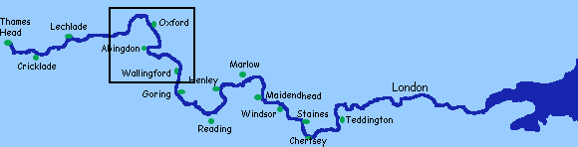 | Date:  Comments:
Reading:  Research an historical building in London – from your research, then create a set of questions which could be given as a quiz to someone else interested in the topic of London. | Date:  Comments:
 |  |  |  | DT:  Make a model of your invention from your English writing task.  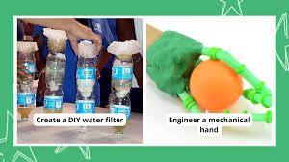  You could make it physically or create a digital model. | Date:  Comments:
 |  | Probability:  There are a range of tasks for you to work on set as a  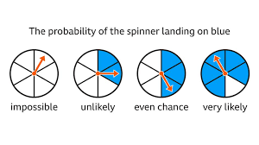  2Do on Purple Mash. | Date:  Comments:
Spelling Practice:  Ask an adult/sibling to write out some of your spelling words for the week (or from the Y5/6 spellings in the back of your homework book) but scramble the letters – can you unravel them? | Date:  Comments:

