English |  | Maths |  | Topic/Creative
Write an informative, clear, bold poster about keeping safe at the seaside. You could include protection from the sun and safety in the water.  Y1: remember to use capital letters and full stops.  Y2: try to use some adjectives. | Date:  Comments: | Create your own fish and chip shop menu.  Y1 – price your items up to 20p. Write how much change you would get from  20p if you buy one or more of the items. Why don’t you try change from 50p?  Y2 – price your items up to £1.00. Write how much change you would get from £1.00 if you buy one or more of the items. Why don’t you try change from £2.00? | Date:  Comments: | Make a sea animal. You can use play dough, lego, clay, papier mache, fabric, plastic bottles etc.  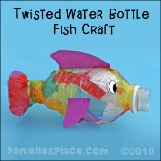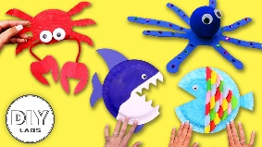 | Date:  Comments:
Talk to older relatives and try to find out where they used to go on holiday. How is it  different from today?  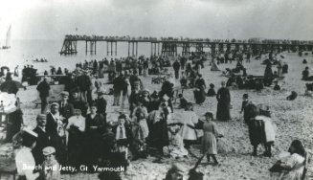 | Date:  Comments: | 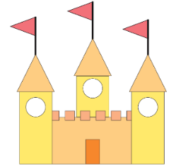  Use 2D shapes to create a sandcastle shape picture. Draw it. Or use 3D shapes to make a sandcastle model. Take a photo.  Don’t forget to label the shapes you have included. | Date:  Comments: | Create a seaside themed healthy snack!  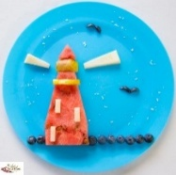  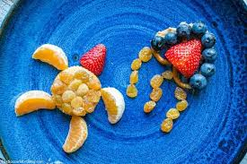  You could use fruits, vegetables or other healthy foods to create sea creatures or features of the seaside. | Date:  Comments:
Write a seaside story! Think about the main character and ensure your story has a beginning, a middle (with a problem and resolution) and an ending.  Yr 1 - focus on noun phrases and handwriting.  Yr 2 - focus on expanded noun phrases, punctuation (!?,.) and writing for impact. | Date:  Comments: | Plan a journey to the seaside including time. Think of 5 things you want to do there and sequence them showing what time you will do each thing e.g. 9 o’clock get the train to the seaside, half past 10 arrive at the seaside…  Y1: use o’clock and half past  Y2: use o’clock, half past, quarter past and quarter to. | Date:  Comments: | 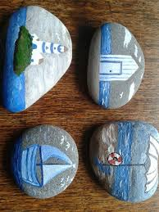  Find a good-sized stone and decorate with a seaside theme using your own choice of media (e.g. paints).  Bring them into school to show us! | Date:  Comments:
Find a seaside themed story, either a book, film, or TV show, and write a book review about it.  Don’t forget to include: who would enjoy it and why, what you enjoyed about it, a star rating.  Y2: also include any links you can make to other books or films. | Date:  Comments: | Number lines: use chalk to work outside or draw out number lines in your book.  Y1: leap along your number line in jumps of 2s, 5s, and 10s.  Y2: leap along your number line in jumps of 2s, 5s, and 10s and then use this to create multiplication sentences. E.g. 1 x 5 = 5, 2 x 5 = 10, 3 x 5 = 15… | Date:  Comments: | 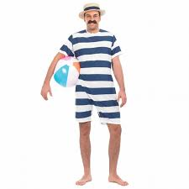  Design your own swimsuit!  It could be a swimsuit from the past (e.g. Victorian period), present day or from the future. | Date:  Comments:
KS1 Homework Grid: The Seaside - History
Please choose one activity a week, and record which activity has been completed by adding the date into the box provided. Please add comments, should you wish to, regarding your child’s engagement/enjoyment/understanding of each activity. Please choose at least two from each column during each half term.

