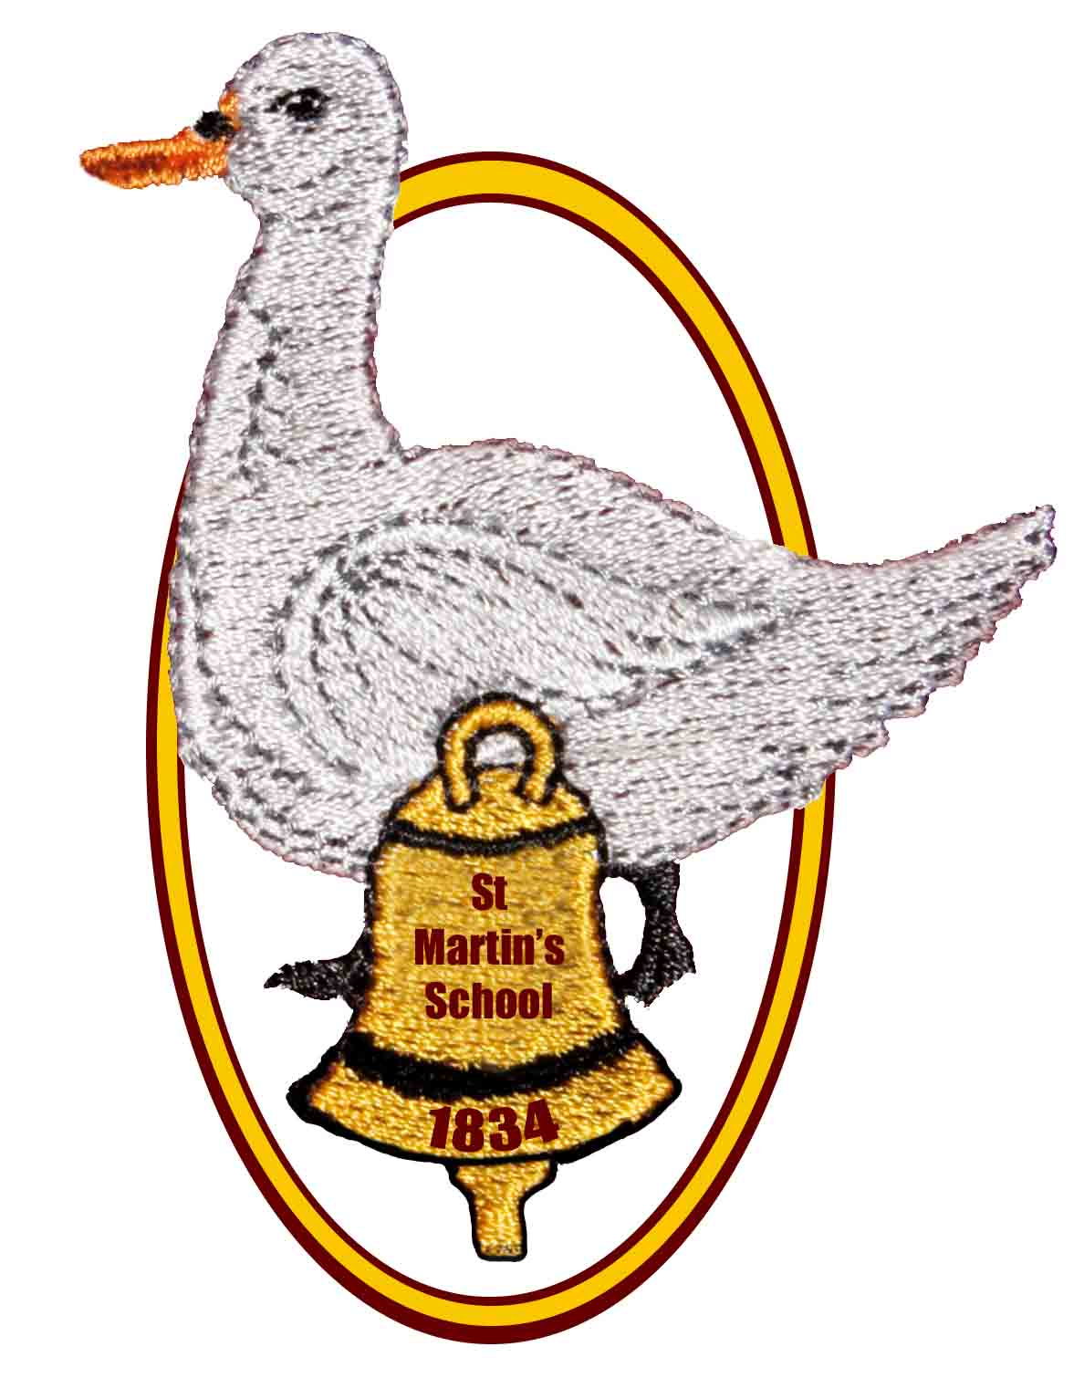

St Martin’s School

Headteacher: Mrs K. Bartlett Chair of Governors: Mrs L Chorley

OPEN MORNING, AFTERNOON AND EVENING

for parents of children who are due to start school in September 2024

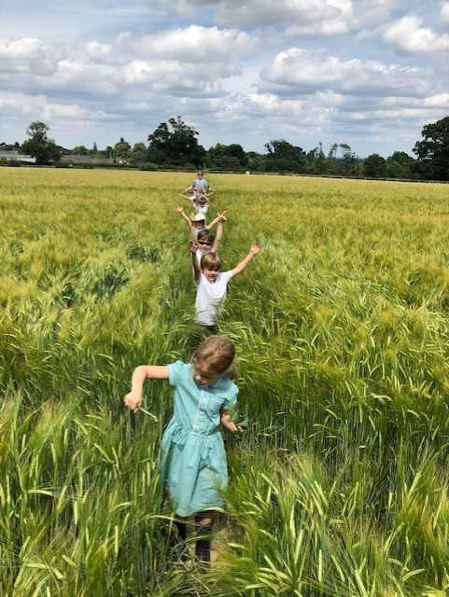We would like to invite you to find out more about

## St Martin’s

## Church of England (Aided)

## Primary School

**East End, Newbury, RG20 0AF**

**on**

**Monday 6th November**

**9.30am, 1:30pm or 6.00pm**

**Each session will start with a short presentation by the Headteacher and Deputy Headteacher, followed by a tour of the school led by our school ambassadors and an opportunity to look round the school grounds. If you would like to attend, please phone the school and let us know. We look forward to meeting you!**



St Martin’s is everything you want in a local village primary school.  It encourages the children to learn, discover, care about others and have fun.  The children run in and come home with stories of a wonderful day!

Year R parent

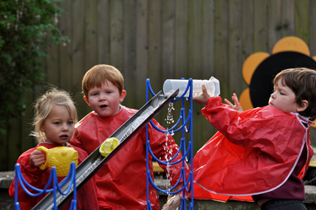

**Come and see our lovely Year R outdoor area, which was installed in October 2021!**

**In the meantime, please explore our school website to find out more about us – there is a special page for prospective parents, which includes the presentation from our previous open events and a video tour of our Year R classroom.**

**If you have any questions or would just like a chat with the Headteacher about our wonderful school,**

**please contact us on 01635 597796**

**or e-mail**

[**adminoffice@st-martins.hants.sch.uk**](mailto:adminoffice@st-martins.hants.sch.uk)