Space!
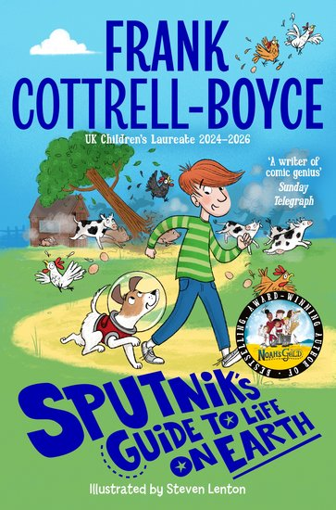
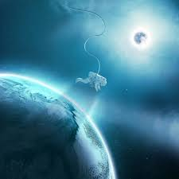

In English writing, we will be…
- Practicing our writing skills by:
- Reading a range of fiction and non-fiction texts linked to space travel and exploration and writing a newspaper report regarding a discovery in space and alien life.
- Using our class reader to drive our writing – Sputnik’s Guide to Life on Earth
- Creating biographies of famous scientists and inventors.
- ALL – revising our knowledge and use of reported and direct speech.
- Y5 – Using commas for clarity. Using a range of devices to create cohesion across our writing.
- Y6 – Using the prefixes (dis, de, mis, over, re). Applying suffixes to converting nouns into adjectives using ate, ise, ify. Revision of a range of EGPS skills.

In English reading, we will be…
- Exploring and analysing a range of non-fiction texts to research space explorers, inventors and scientists.
- Sharing in group reading of Sputnik’s Guide to Life on Earth to practice our oracy skills.
- Examining and evaluating the features of newspaper articles – both in print and digital.
- Using the different ‘Reading Roles’ to help us answer comprehension questions.

In English Grammar, Punctuation and Spelling, we will be…
- Reviewing our previous learning including word classes.
- Y5 learning how to apply the prefixes un-, de-, dis- and mis-.
- Y6 revising spelling rules.
- Practising Y5/6 spelling words: accommodate, appreciate, exaggerate, criticise (critic + ise), desperate, environment,
equip (–ped, –ment, government, parliament

In Mathematics, we will be…
- Place Value: reinforcing our knowledge of multiplication and division through our understanding of factors, multiples, prime, square and cube numbers and our ability to reason and problem solve.
- Fractions: Y6 – revising and applying our knowledge of working with fractions and all four operations using real-life contexts.
- Geometry: Y5 – extending our knowledge of coordinates in the first quadrant and linking this to reflection and translation of regular and irregular polygons.
- All 4 operations/problem solving: thinking flexibly and applying different approaches by breaking down problems into a set of smaller steps. Solving addition and subtraction multi-step problems linked to statistics.
Y6 – to include expressing problems algebraically.

In PSHCE, we will be…

Exploring global issues around community cohesion ad diversity.

Identifying and discussing similarities and differences between the ways in which people around the world have access to healthcare, education etc and why these inequalities occur.

In French, we will be…
- Naming and describing the weather, sports and music.

In Music, we will be…
- Singing performance?

In RE, we will be…
- exploring how devotion is shown across many faiths with a focus on Hinduism and the devotion shown to Krishna.

In PE, we will be…
- Progressing our skills for a arrange of athletics activities with a focus on self-challenge and improvement.
- Identifying and discussing bowling and striking strategies within the game of cricket to develop our game as an individual and as a team.

In Computing, we will be…
- Using spreadsheets to represent a variety of date sets in different ways and analysing their purpose, audience and suitability.

In Science, we will be…
- Revising our understanding of what the solar system, forces within space and the timeline of humankind’s exploration of space.
- Using our mathematical skills to understand the distances between different parts of the solar system, time periods for space travel and fuel consumption etc.

In Design Technology, we will be…
- Revising our sewing skills with a range of stitches to plan, design and create a logo for an astronaut’s space suit.

This term’s vocabulary will be…
Solar system, planets, gravity, exploration, sun, moon, orbit, light year, propulsion, satellite

