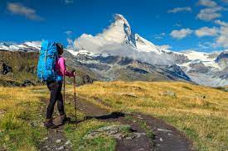
Willow Homework Grid: Alpine Adventures
English |  | Maths |  | Topic/Creative
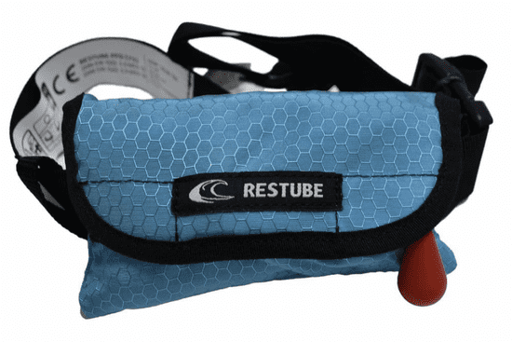  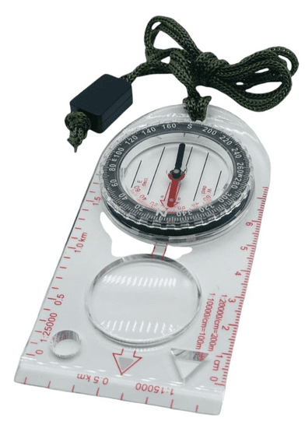  Writing:  Survival equipment – explanation.  Can you choose a piece of existing survival equipment (first aid kit, water purifier, compasses) or create a brand new item and then write your own explanation text? Include an introduction to explain its purpose, detailed explanations of its key features and how it should be used. Labelled diagrams/ drawings will add further clarity for your reader. Think about the layout, level of formality, technical vocabulary and use of punctuation – particularly parenthesis! | Date:  Comments: | 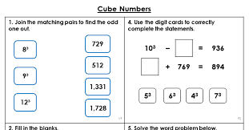  Squares and Cubes:  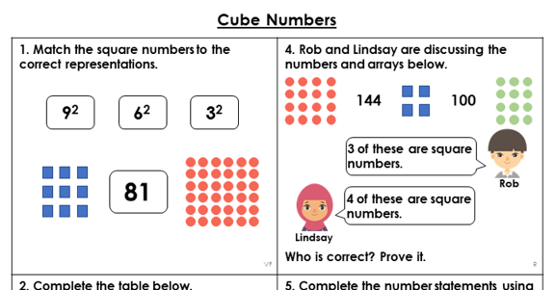  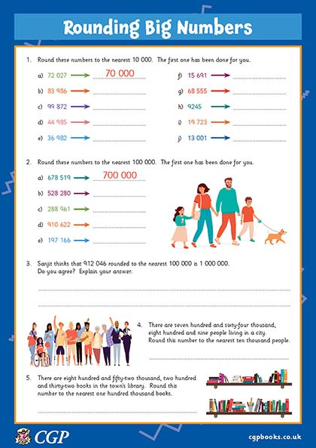  Rounding: | Date:  Comments: | 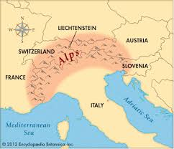  Geography: can you research which mountains are part of the Alps and create an information sheet to compare and contrast them?  You could include pictures/photographs, key features and statistics. You could even create a bar graph to show the differences in heights, or, a line graph showing the change in temperature across the year. | Date:  Comments:
 |  |  |  | Science – research and create a poster about your favourite animal, including the group which the animal belongs to and how you know this, where the animal lives, what the animal likes to eat and if it is an omnivore, carnivore or herbivore and the features that the animal has to help it survive. | Date:  Comments :
Writing: Adventure diary  Using the reading we have done from Survivors and Heroes and our learning about the Alpine Region, write a diary entry based on an outdoor adventure. Consider how the weather, terrain and season would affect your progress. Use the senses to develop description and personal reflections/rhetorical questions to show the effect it is having on you. | Date:  Comments: | Statistics:  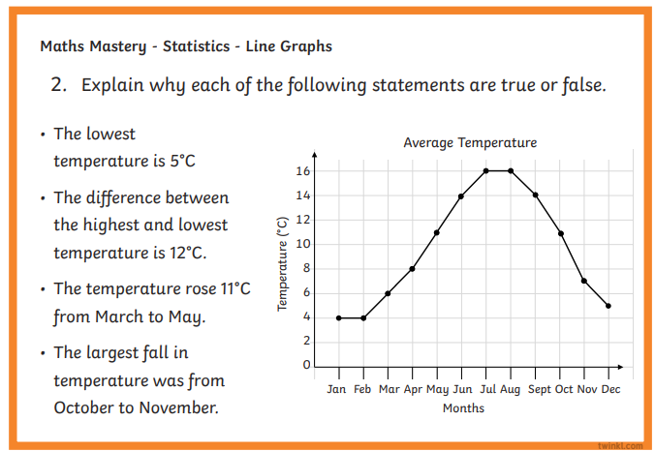 | Date:  Comments:
 |  |  |  | Art and Design:  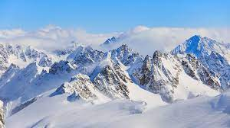  Use media of your choice to create your own sculpture of the Alps. Think about how you will create the proportional sizes, texture and tones of the different mountains or focus on one particular parts and present its particular individual features. | Date:  Comments:
Reading:  Find a non-fiction text, such as a biography about a famous adventurer. Use your Reporter skills to find out some main facts about them: where/when they were born, their interests as they grew up; locations they have been to; any exciting/dangerous events that have happened to them on their adventures and what motivates them to go on these challenging expeditions. | Date:  Comments:
 |  |  |  | PSCHE / Family Discussion activity:  Is there only one type of family?  Do stereotypes about families exist?  Why and what impact can these have on people?    How can we be supportive to people from different backgrounds/families and discourage stereotypes? | Date:  Comments:
 |  | 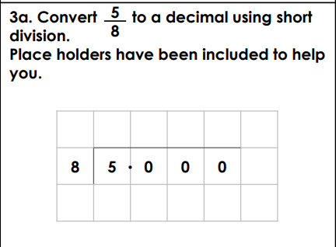  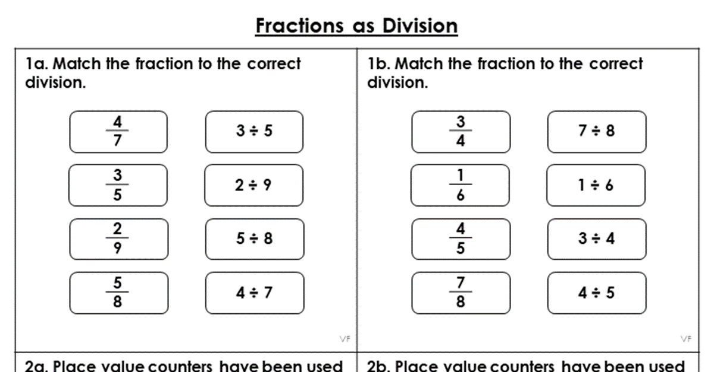  Fractions:  Can you now convert 4/6, 2/5, 3/9 to decimals using this method? How would you check your answer?  Multiplication/Division – Purple Mash tasks. | Date:  Comments:
Spelling Practice: include your focus words in sentences which use past and present perfect tense.  Y5 - Y5/Y6 words embarrass, environment, equip, equipped, equipment, especially.  Y6 - Y5/Y6 words  Government, guarantee, harass, hindrance, identity, immediate, immediately, individual. | Date:  Comments:
Date:

Comments:
I I did this independently with no help.
S I did this with some support.
H I needed lots of help and found it tricky.

