Gonna Sing! by Robin Scott
(for Lynn)

Ev’rybody get together
Let's make the world all right
Let's fill this place with Music here tonight
Ev'rybody gonna sing as one
Ev'rybody gonna dance
Ev'rybody gonna feel alright let's take that chance
So Sing it out
Sing it Strong
So ev'ryone can singalong

We're gonna sing 'til the world is singing
Gonna make it a joyful noise
Let's hear the voices ringing
All the girls and boys
Gonna play 'til the world is dancing
Gonna make it a joyful sound
Let's send it Rocking around the World
Round and Round and Round
From the Sky to the Ground!
Hey! Hey! Hey!
Hey! Hey! Hey!

Come on let's get together
Ev'rybody as one
We can sing and dance tonight and have some fun
So Sing it out
Sing it Strong
So ev'ryone can singalong
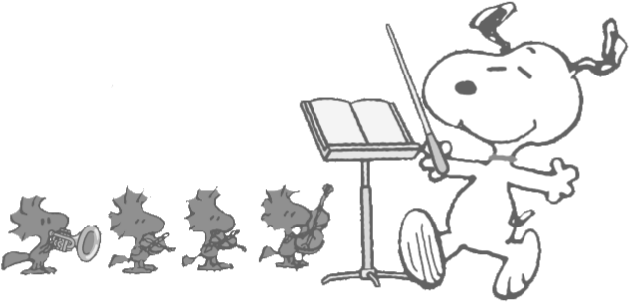

We're gonna sing 'til the world is singing
Gonna make it a joyful noise
Let's hear the voices ringing
All the girls and boys
Gonna play 'til the world is dancing
Gonna make it a joyful sound
Let's send it Rocking around the World
Round and Round and Round
From the Sky to the Ground!
Hey! Hey! Hey!
Hey! Hey! Hey!

We're gonna send it rocking around the world
We're gonna send it rocking, rocking
We're gonna send it around the world!

Gonna sing 'til the world is singing
Gonna make it a joyful noise
Let's hear the voices ringing
All the girls and boys
Gonna play 'til the world is dancing
Gonna make it a joyful sound
Let's send it Rocking around the World
Round and Round and Round
From the Sky to the Ground
Round and round and round and round and round and round and round!

