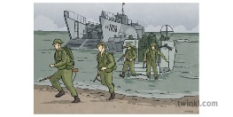
Willow Homework Grid: Who’s In Charge?
I I did this independently with no help.
S I did this with some support.
H I needed lots of help and found it tricky.

English |  | Maths |  | Topic/Creative
Writing:  - Write a diary entry from the perspective of a London evacuee, being sent to East Woodhay for safety. Remember that life was very different during WW2.  - Write a poem about World War Two.  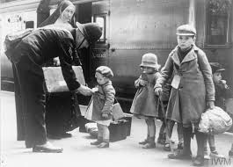 | Date:  Comments: | Geometry:  Photograph and measure angles around your house. Can you create missing angle questions to go with your pictures?  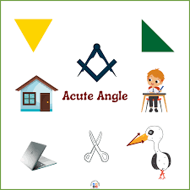 | Date:  Comments: | DT:  Find a war time recipe, preferably a rationing recipe. Write the recipe up and have a go at making it. Does it taste as nice as modern recipes?  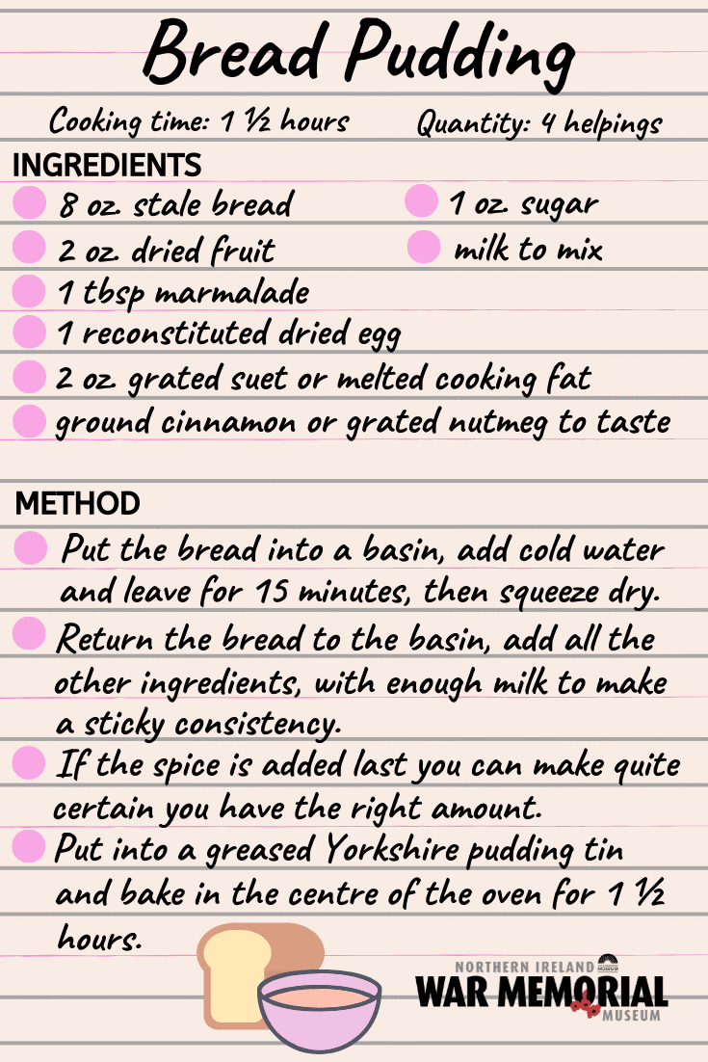 | Date:  Comments:
 |  |  |  | PSCHE / Family Discussion activity:  Discuss the pros and cons of children being evacuated during the Second World War.  Consider the new experiences and environments children from cities would have had and also the issues that may have arisen being away from their families. Remember, there were no devices to stay in personal contact like we can today. | Date:  Comments:
Grammar: punctuation  Write a newspaper article informing the public about the outbreak of World War Two. Use direct and reported speech. | Date:  Comments: | Finances:  The average wage in 1945 was £164 a week. Can you look online, with adult support, and find what you could buy each week with your money. Don’t forget to include rent!  Here is a website that converts a specific amount into the goods you could buy: https://www.nationalarchives.gov.uk/currency-converter/   | Date:  Comments:
Creative text: Write your name and a message to a loved one using a made up code you create with symbols, shapes or numbers.  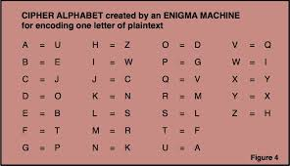 | Date:  Comments:
 |  |  |  | Art/DT:  Create a poster encouraging children of the cities to evacuate to the countryside.  Remember it needs to be persuasive.   | Date:  Comments:
 |  | Computing/Maths:  Hit the Button challenge: https://www.topmarks.co.uk/maths-games/hit-the-button | Date:  Comments:
Spelling Practice:  Draw out a table with two headings (tious and cious). Write as many words as you can under each heading - a minimum of 5 under each. Pick one from each side and draw a picture to represent what that word means. | Date:  Comments:

