English |  | Maths |  | Topic/Creative
On the computer or using books, research Mary Seacole and create a fact file giving information about who she was, what she did, how she helped people etc.  Your fact file could be made on the computer and printed for your homework book, or written. | Date:  Comments: | Number bonds - Practise your number bonds by creating bingo cards for number bonds to 10 and 20.  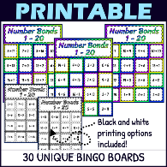 | Date:  Comments: | Florence Nightingale was nicknamed the ‘lady of the Lamp’.  Make a paper lantern and bring it in to hang up in the classroom.  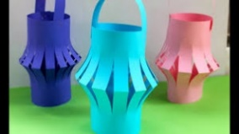 | Date:  Comments:
You’re a nurse at a busy hospital.  Write a diary about what it is like working there.  https://www.bbc.co.uk/bitesize/articles/zfwht39    Try to use the conjunctions (and, but, because) to extend your sentences. | Date:  Comments: | 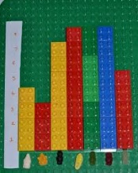  Create a block graph – Look in your fruit bowl, take a handful of lego, collect leaves and look at their shape, use tins from the cupboard to count. Make a tally chart and then create a block graph about your findings. | Date:  Comments: | Learn to change your bed like Florence did for the soldiers.  Take a photo of you in action!   | Date:  Comments:
Imagine being an injured soldier.  Write a letter home about your experience in hospital and how Florence Nightingale has helped you.  Don’t forget to use your expanded noun phrases! | Date:  Comments: |   Money – Make a gift shop. Add items (cards, flowers, teddy, chocolate) that might help people feel better quicker. Create prices. Practise finding different amounts of money. Can you give change from 20p? 50p? or even £1? | Date:  Comments: | You are a reporter, reporting on Florence Nightingale’s work on the Crimean War!    Make a video of the extraordinary work she is doing there. | Date:  Comments:
How to treat an injury.  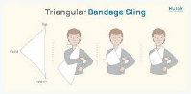  Write a set of instructions on how to treat an injury of your choosing.  Don’t forget to use bossy verbs (wash, dry, wipe, clean) and time connectives (first, next, then, after that, finally)! | Date:  Comments: | Make your own board game to keep the soldiers entertained!  This must include two dice and creating your own board which goes up to 50.  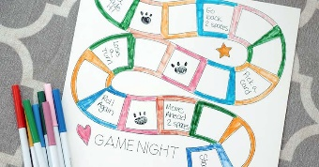 | Date:  Comments: | Supermarket Plants  Visit a supermarket. Find different plants you can eat, including herbs, fruit and vegetables. Discuss which part of the plant they are? Roots? Leaves? Flower? Stem? Draw, write or take a photo of the different plants you have seen. | Date:  Comments:
Homework Grid Spring 2: Courageous Advocates
Please choose one activity a week, and record which activity has been completed by adding the date into the box provided. Please add comments, should you wish to, regarding your child’s engagement/enjoyment/understanding of each activity. Please choose at least two from each column during each half term.

