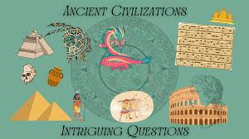
Willow Homework Grid: ‘Ancient Civilisations’
I I did this independently with no help.
S I did this with some support.
H I needed lots of help and found it tricky.

English |  | Maths |  | Topic/Creative
Writing:  After reading Marcy and the Riddle of the Sphinx – can you create your own story that contains a riddle? It could be based on the Egyptians or a topic of your choice. Can you write it with a specific audience in mind (a family member or friend) that you know well and can create a riddle that is specific to them?  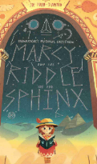  You can illustrate your story and even leave clues in the pictures. | Date:  Comments: | Place Value: Rounding on Purple Mash.  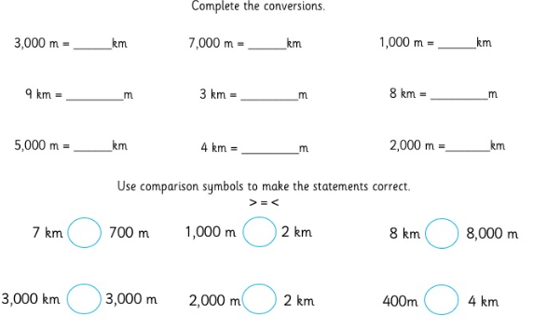 | Date:  Comments: | Science:  Create a table that shows how many different materials you can find in your home and how you would classify them. Think about what their properties are and how this makes them useful. Can you compare different groups of items with each other? What seems to be the most popular material and why do you think this is? Have they got any weaknesses? Do you have any ideas for different materials that could be used – especially more eco-friendly ones?  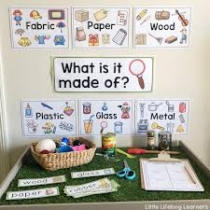 | Date:  Comments:
Reading:  Once you have written your riddle story, find a time to read it to them using the skills we have practised in school for expression, pace, tone and volume. How exciting can you make it seem? Are their parts when it needs to be mysterious, scary or shocking?  Ask the person you read to to write a comment in your homework book about their favourite part of the story AND how your reading of it made it even better! | Date:  Comments: | 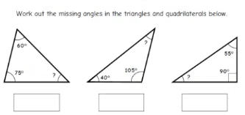  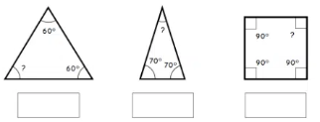  Angles: | Date:  Comments: | History  Create a presentation based on an Egyptian artefact you have researched. You could make a model; labelled diagram, a spoken explanation; write a song; create a PowerPoint or a digital representation – you can present your artefact in more than one way! You need to explain what it is, what it does, what it was made from and who used it and why. Explain where examples have been uncovered and when.  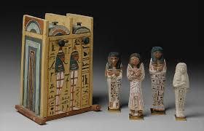  We will have an afternoon at the end of term to share them all in our own Museum show! | Date:  Comments:
Writing:  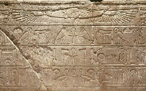  Can you write in hieroglyphics? Use this link to help you translate a paragraph from your favourite story: https://www.penn.museum/cgi/hieroglyphsreal.php | Date:  Comments:
 |  |  |  | Art and Design:  Does your family know any dishes from other cultures that contain unusual ingredients? You can write out the recipe or make it and take photos! | Date:  Comments:
 |  | Time: create a timetable of a day in your household. You could challenge yourself and create it for multiple days. Show how long the different activities and events take – can you write down the time intervals for each one and compare them against each other? Y6 – make sure you use the 24 hour clock!  Time Saturday Sunday  07:30-08:00 Shower Read in bed  08:00-09:00 Have breakfast and help tidy. Make breakfast with Mum  09:00-10:30 Take a walk to the park. Practise my Instrument. | Date:  Comments:
 |  |  |  | PSCHE / Family Discussion activity:  How do you and your family use social media? Can you have a debate about the positives and negatives of its existence.  Try and talk to someone in your family who has knowledge of what is was like before social media and how people communicated differently. What impact does your family think it has had on people’s wellbeing and how can we be sure it is used in the right way? | Date:  Comments:
Spelling Practice:  explanation, competition, profession, marvellous, disastrous, mischievous.  Can you write a short story relating to our science topic that contains all these spellings words and makes sense? | Date:  Comments:

