Homework Grid Summer 1 – Uganda
Please choose one activity a week, and record which activity has been completed by adding the date into the box provided. Please add comments, should you wish to, regarding your child’s engagement/enjoyment/understanding of each activity. Please choose two from each column during each half term.
English |  | Maths |  | Topic/Creative
Try a new fruit or vegetable you haven’t eaten before.  Write a few sentences to describe what it tastes like? Do you like it? Does it taste like a fruit or vegetable you have already tried? | Date:  Comments: | Each African country has its own flag of meaningful colours: green symbolizes growing things, yellow symbolizes the sun, red the blood of the people, blue the sea, white peace, and black the people or African freedom.  Have a go at creating your own flag, be sure to explain what the colours used mean to you!  Can you make it symmetrical? Write down which shapes you have used?  Year 3 - How many right angles have you used? | Date:  Comments: | Listen to some African music. Do you like the music? Can you copy the beat? Can you create your own African inspired musical instrument using junk modelling?  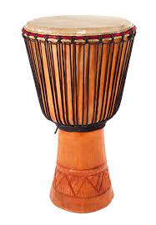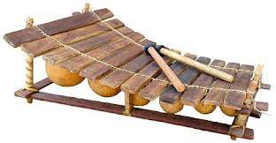 | Date:  Comments:
How many fruits or vegetables can you name against the letters of the alphabet?  A is for apple  B is for banana …  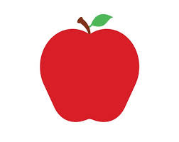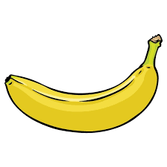 | Date:  Comments: | Year 1 – Make towers using toys, can you compare the lengths and heights? Which is taller/longer or shorter?  Year 2 – Draw two lines using a ruler in your books and compare the lengths in cm. Can you draw lines twice as long or half as long as another?  Year 3 – Draw 2D shapes in your books using a ruler, can you measure the perimeters and identify right angles and angles less than or greater than right angles? | Date:  Comments: | Create an African animal or diorama out of junk modelling and craft materials.  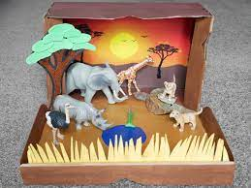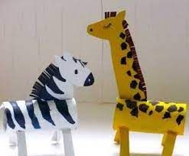 | Date:  Comments:
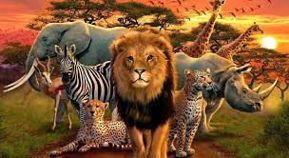  Research using books or the internet and create an information poster on an animal which is found in Africa, remember to include facts and pictures! | Date:  Comments: | Year 1 - Recognise all coins, make different amounts with coins up to 20p. Can you give change from 10p/20p?  Year 2 - Recognise all coins, make different amounts with coins up to £1. Can you give change from 20p/50p/£1?  Year 3 – Solve addition and subtraction number sentences including £’s and p’s. | Date:  Comments: | Look at African bead work and have a go at making your own bead or painted penne (or other dried foods) jewellery.  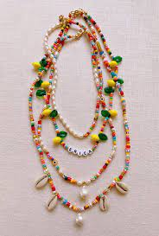  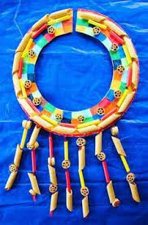 | Date:  Comments:
Write a letter you would send to a child at Bukuya School. What would you ask them about their school? What could you tell them about St Martin’s school? | Date:  Comments: | Year 1 – Practise counting in 2s from any number, 5s and 10s. Challenge can you count in 10s from any number e.g. 3, 13, 23, 33 etc.  Year 2 – Practise your 2, 5 and 10 multiplication and division facts.  Year 3 – Practise your 3, 4 and 8 multiplication and division facts. | Date:  Comments: | Look at google earth with a family member and find Africa.  Draw a map of Africa. Label the oceans and at least two of the countries. Discuss and describe the different human and physical features you can see. | Date:  Comments:

