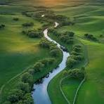
Willow Homework Grid: Go With the Flow.
I I did this independently with no help.
S I did this with some support.
H I needed lots of help and found it tricky.

Writing:  1, Create a mini poem or river diary entry using adverbs to describe a journey from source to sea. You could also use personification to characterise the river.  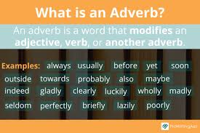  2. Write 5 sentences about rivers using adverbs to describe how water flows, moves, or changes in our daily lives (e.g. “The water rushed swiftly through the pipes and out through the shower head.”) | Date:  Comments: | Maths – Fractions, decimals and percentages.  - Create a poster or infographic showing how fractions, decimals and percentages are used in real life (e.g. shopping, sports, weather).  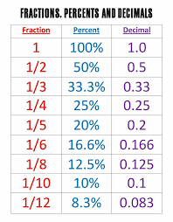  - Convert these 5 fractions into percentages and decimals and explain how you did it (e.g. ¾ = 75% = 0.75). Represent each on with a bar model.  - 1/5 b) ¾ c) 2/6 d) 4/8 e) 4/6  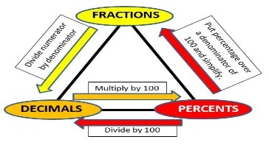 | Date:  Comments: | Science: Create a movement experiment at home and record what you discovered. Here is one idea using everyday items (ask an adult first!).  Ramp Races  Materials: Books, cardboard, toy cars or balls.  Build ramps at different angles using books and cardboard  Race toy cars or balls down each ramp  Observe which ramp makes them go faster or slower – Why? What forces are in effect? How did you make your experiment fair?  - Try different surfaces (carpet, foil, sandpaper) – what differences do you notice? Why?  - Challenge – can you present your data in a graph? Explain which type of graph you chose and why? | Date:  Comments:
 |  |  |  | PSCHE / Family Discussion activity:  - Interview someone at home about a stereotype they’ve seen or challenged.  - Why did they think it was important to challenge it?  - What did they hope would change after they challenged it?  Share what you learned in a presentation of your choice.  2. Go on a walk to a water source in your local area – can you see any evidence of the effects of modern-day human activity on this environment? What impact do you think it has on the wildlife, wider environment and the water quality? | Date:  Comments:
GPS: Identify the subject and object in 5 sentences about forces.  - The magnet attracted the paperclip.  - Gravity pulls the apple towards the ground.  - The child pushed the toy car across the floor.  - Friction slowed the bicycle on the gravel path.  - The wind lifted the kite high into the sky.  Year 6 challenge: can you convert these sentences from active to passive voice? | Date:  Comments: |  | Date:  Comments:
Date:

Comments:
 |  |  |  | Time: “My Week as a Travel Agent!”  Create a fictional travel timetable for a week of exciting journeys that follows the path of a particular UK river:  Choose 3–5 destinations along the route (e.g. London, Windsor, Henley-On-Thames, Reading, Oxford for river Thames). You could link it to the Art/DT task.  Use made-up departure and arrival times for trains, buses, or coaches.  Include a table with:  Day  Departure Time  Arrival Time  Duration  Mode of Transport | Date:  Comments:
 | Date:  Comments: | Spelling Practice:  Find and sort 10 words with the suffixes: -tion, -sion, -cian, -ssion. Write them in rainbow colours or pyramid style to help you memorise them.  Hold a spelling bee with someone in your family based on these Year 5/6 spelling words:  explanation, competition, profession, marvellous, disastrous, mischievous | Date:  Comments:
Art/DT: Create a 3D model or drawing of a river showing how it is used as a natural resource (e.g. for farming, drinking water, transport) | Date:  Comments:

