Homework Grid Spring 1: Let it Snow!
Please choose one activity a week, and record which activity has been completed by adding the date into the box provided. Please add comments, should you wish to, regarding your child’s engagement/enjoyment/understanding of each activity. Please choose at least two from each column during each half term.
English |  | Maths |  | Topic/Creative
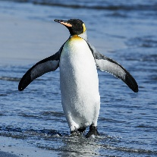  Research penguins  Write instructions on how to care for a penguin. You will need to include information about:  - what they eat and when?  - where do they live?  - what do they like to do? | Date:  Comments: | ‘Cool’ number! Choose a number between 1 and 100. Investigate it - what can you say about it?  Double, half, 1 more, 1 less, 10 more, 10 less, how many tens, units, addition and subtraction number sentences…what else can you show? | Date:  Comments: | Polar Animal Food Chain  Choose an Antarctic animal. Draw and label your food chain for them. Think carefully about each step. Look at examples of food chains here:  https://www.bbc.co.uk/bitesize/topics/zbnnb9q/articles/zwbtxsg | Date:  Comments:
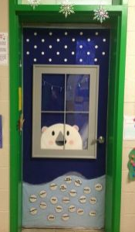  A Polar Bear arrives at your front door.  Write a story about an adventure you have together. Try to use conjunctions (and, but, because) to extend your sentences. | Date:  Comments: | Cooking – Warm Soup    A cold explorer needs a soup to warm up. Make your own. Measure out the ingredients in grams / g (if a solid) or millilitres / ml (if a liquid). Record how much you have used.  For example: 100g of potato, 200g of carrots, 500ml of water | Date:  Comments: | 3D Junk Model Igloo  Use cotton wool, papier mâché and/or any other materials you can find around the house to create your igloo masterpiece!  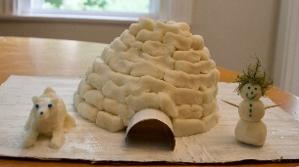 | Date:  Comments:
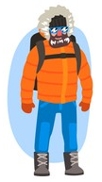  You’re a polar explorer.  Write a diary entry or a postcard about an adventure you’ve had.  Did you climb a mountain?  Did you spot some narwhals?  Did you make friends with a penguin?  What did you have for tea? | Date:  Comments: | Penguin Diary  Help a King Penguin plan his day. Draw an analogue clock face for each activity. Write the time underneath (hour, half past). Add an extra challenge by using quarter past and quarter to.  When did he wake up / go to sleep? When does he fish, eat, slide around the ice?  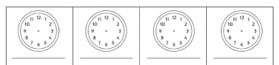 | Date:  Comments: | Frozen Toy  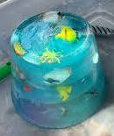  Freeze a plastic toy in a container of water. Then, try and find the most effective way to defrost him! Record how long it takes for your different shaped ice cubes, created by freeing your toy, to melt back into water! Can you record this information on a table or chart? | Date:  Comments:
Polar Animals Poem  Write a poem of your choice about an animal that lives in the polar regions. Think about including similes as well as alliteration.  Just remember – not all poems need to rhyme!  We just want you to use poetic language, for example: adjectives, alliteration and similes. | Date:  Comments: | Hit the Button!  https://www.topmarks.co.uk/maths-games/hit-the-button  Practise your maths skills online:  - Number Bonds to 10 & 20  - Doubles  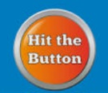  - Times Tables - 2s, 3s, 5s, 10s | Date:  Comments: | Snow Scene  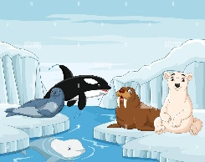  Use objects from around your house to create a snow scene. You could use white sheets for snow, dress in your warmest winter clothes and use any Polar Region teddies you have! Take a photo. | Date:  Comments:

